|  |
| --- |
| **North South University**  Department of Electrical & Computer Engineering  **PROJECT PROPOSAL**  CSE311L: DATABASE MANAGEMENT SYSTEMS (LAB)  SECTION: 07 GROUP: 09  SEMESTER: FALL 2022  PROJECT PROPOSAL ON ***“Online Flight Booking Management System***”  **Submitted By:**  NAME ID  Md. Baker 1911672642  Tasdeeq Jawad 2011020042  Rezuan Islam Samir 2021092642  **Course Faculty:**  Dr. M. A. Rouf (MdAr)  **Lab Instructor:**  Fahimul Hoque  Submission Date: 5th November, 2022 |

**INTRODUCTION:**

***Online Flight Booking Management System*** can save time and money for both the user and the airline company by creating a more user-friendly environment. This project attempts to recreate the fundamental concepts of the booking system for airlines.

Our system for booking airline tickets offers these features: -

*Customers can:*

* Create an account
* Find flights that are available to a specific city or city-pair
* Tickets can be purchased in the class they prefer
* Cancel reserved tickets
* View the history of booked tickets

*Administrators may:*

* Add/Modify flight schedules, city, price & other related info.
* The stats for booked tickets can be viewed.

Admin is the primary authority for the expansion, cancellation and modification of flights as needed.

**TOOLS AND RESOURCES:**

* + HTML
  + MySQL
  + PHP
  + WEB SERVER

**CHALLENGES:**

As our database contains a lot of information, the main challenge here will be the money. We have to pay a lot of money to handle this kind of database. Besides, we use the online transactions system of money, and it will be a little challenging to maintain it properly. If we are taking information from people, we have to justify whether the information is real or fake. So sometimes it won't be easy. As our primary focus is customer usage, the project should be simple so everyone can use it.

**Project Diagram:**

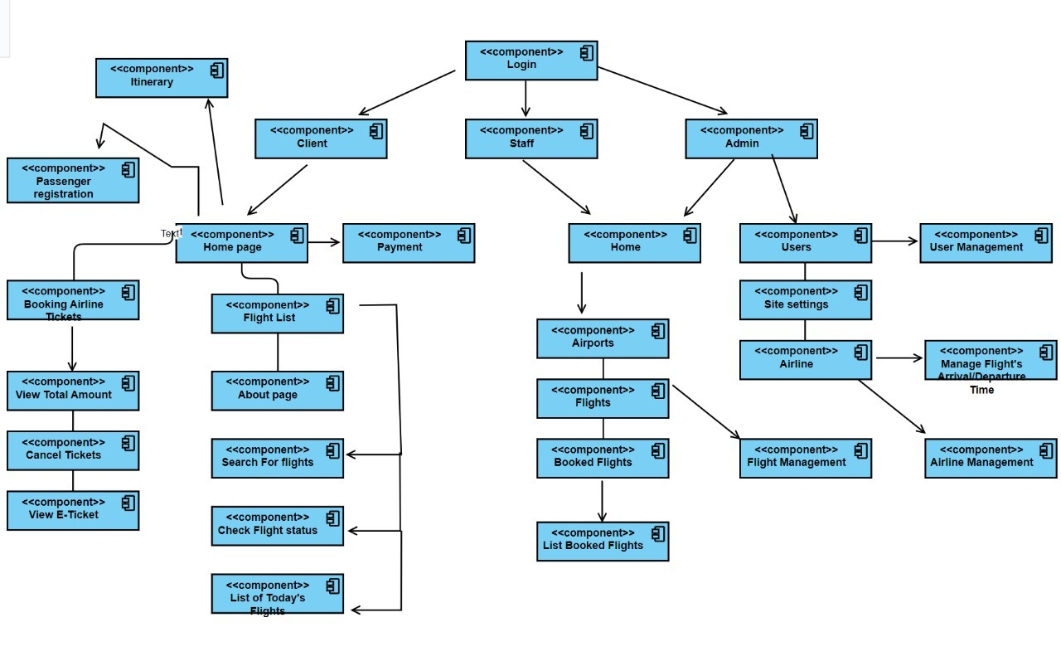

**Requirement Analysis of the Project:**

|  |  |  |  |  |  |  |  |  |  |
| --- | --- | --- | --- | --- | --- | --- | --- | --- | --- |
| **Home** | |  | | | |  | | | |
|  | | **Account Management** | | | |  | | | |
|  | |  | | | | **Register for Customers** | | | |
|  | |  | | | |  | | *Customer needs Phone Number/Email and new password to register. Customer needs to fill the about his/her information.* | |
|  | |  | | | | **Register for Admin** | | | |
|  | |  | | | |  | | | *Admin needs Phone Number/Email and password to register. Admin needs to fill the information about his/her position and expertise.* |
|  | | **Sign In** | | | |  | | | |
|  | |  | | | | *Whenever Customer sign in with Phone Number/Email and password, they will be redirected to the corresponding account home page.* | | | |
|  | | **FAQ** | | | |  | | | |
|  | |  | | | | *If Customer fails to remember his/her password, he/she shall contact Admin or contact via Contact Us features.* | | | |
| **Account Home:** | | | **(Customer)** | | | | | | |
|  | | | *This page acts as a dashboard for the customer. It contains several options like- profile, Flight List Page, Search for Flights and account information. If a customer clicks on any of this option s/he will be redirected to that page.* | | | | | | |
|  | | | **Profile** | | | | | | |
|  | | |  | *This will contain a customer’s information. By clicking one of them, s/he will be redirected home for that class. It will have options like- full name, address, gender, email, profile picture, other information etc.* | | | | | |
|  | | |  | **Full Name** | | | | | |
|  | | |  |  | | | *It will contain Customer’s full name. s/he can also update it.* | | |
|  | | |  | **Address** | | | | | |
|  | | |  |  | | | *It will contain Customer’s present address, permanent address.* | | |
|  | | |  | **Gender** | | | | | |
|  | | |  |  | | | *Customer has to set a gender according to themselves.* | | |
|  | | |  | **Email** | | | | | |
|  | | |  |  | | | *Customer has to provide an email address for notifications and other stuffs.* | | |
|  | | |  | **Profile Picture** | | | | | |
|  | | |  |  | | | *Customer has to set a profile picture so that s/he can be verified easily.* | | |
|  | | |  | **Other Information** | | | | | |
|  | | |  |  | | | *This will contain the other information like date of birth, blood group etc. which will be updated in future for good purpose.* | | |
|  | | | **Flight List** | | | | | | |
|  | | |  | *The page where all available flights are listed.* | | | | | |
|  | | |  | **Booked Flights** | | | | | |
|  | | |  |  | | | *All booked flights are listed along with the flight information and passenger information* | | |
|  | | | **Cancel Tickets** | | | | | | |
|  | | |  | *Customers can cancel his/her tickets.* | | | | | |
|  | | | **View Total Amount** | | | | | | |
|  | | |  | *Customer can view total amount of ticket price.* | | | | | |
|  | | | **Airports Page** | | | | | | |
|  | | |  | *The airports and their locations are listed and can be managed.* | | | | | |
|  | | | **FAQ:** | | | | | | |
|  | | |  | *Customer can update their profile information’s. AND customer can save time and money by booking advanced tickets.* | | | | | |
|  | | |  |  | | | | | |
| **Admin:** |  | | | | | | | | |
|  | *Admin will be able to see the necessary information’s of customer. After logging in s/he will be redirected to the admin home page.* | | | | | | | | |
| **Admin home:** |  | | | | | | | | |
|  | *This is dashboard for the admin. This contains links to the several pages for various purposes Customers list, public notifications, username and password reset for customers etc.* | | | | | | | | |
|  | **Customer list:** | | | | | | | | |
|  |  | | | | *This will list all customers that registered. S/he can create, activate and deactivate any user.* | | | | |
|  | **Public Notification:** | | | | | | | | |
|  |  | | | | *S/he can send notification to any customer or every customer.* | | | | |
|  | **Username-password-reset:** | | | | | | | | |
|  |  | | | | *If any customer faces issues like “username forgot” or “password forgot”, s/he can request admin for reset that.* | | | | |
|  | **Admin Info** | | | | | | | | |
|  |  | | | | *This will contain sensitive information about admin like password, first email, second email and contact info etc.* | | | | |
|  | **Admin password reset:** | | | | | | | | |
|  |  | | | | *If admin forgets his password, he will be redirected too here. S/he will be needed all the info except the password to reset the password.* | | | | |

**Gantt Chart:**

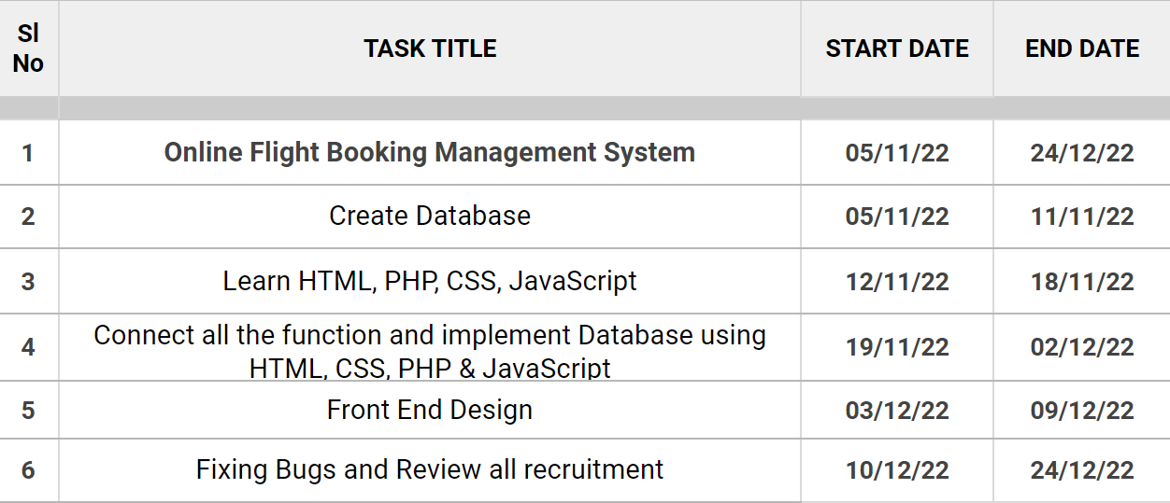

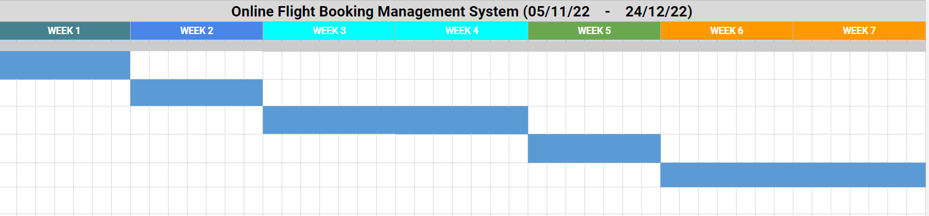

**GitHub-Link:**

https://github.com/MdBakerFarhad/CSE311_SEC-7_GROUP-09_PROJECT